Hospital Appointment Booking
Project: MedCare | Technology: HTML, CSS, JavaScript (localStorage)

Aim
To build a hospital appointment booking system for patients, doctors and hospital admin with slot management.

Algorithm
- Start: load doctors, departments and appointments.
- Patient logs in, selects department and doctor.
- Generate the doctor's slots; check slotFree for the chosen date.
- Patient books a slot; appointment saved as Pending.
- Hospital/admin updates status: Approved, Rejected or Completed.
- Patient views appointment history and status.
- Save data to localStorage. Stop.

Result
The Hospital Appointment Booking was implemented successfully using HTML, CSS and JavaScript. All modules (login, role-based pages, data entry, search/booking and admin management) work correctly in the browser, and data persists using localStorage.

Implementation (Output Screenshots)
Home page
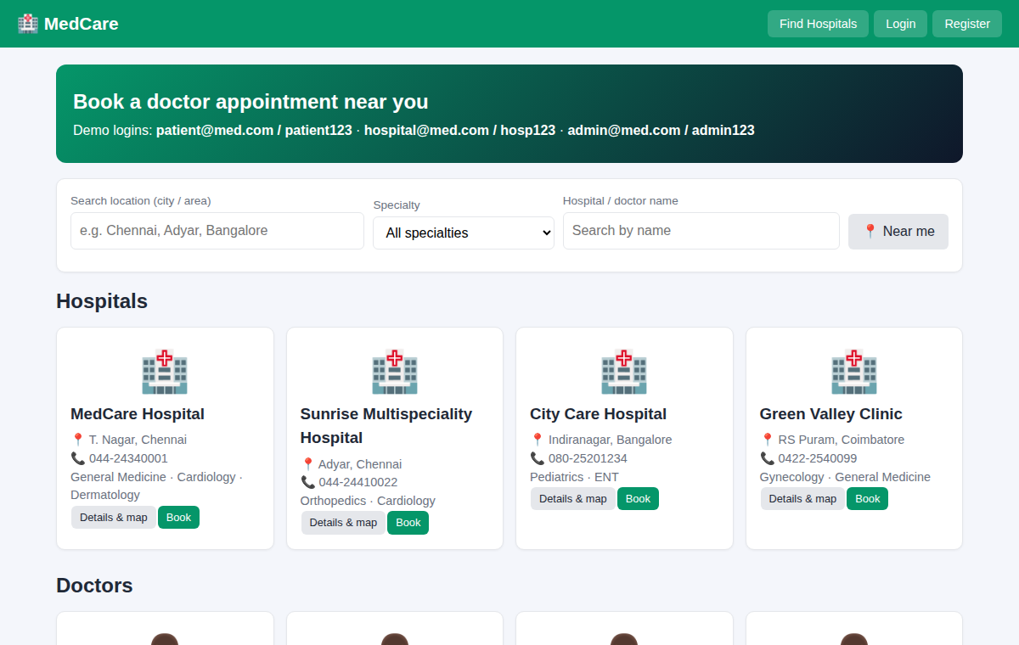
After login (admin / dashboard)
